**Project Design Phase-II**

**Data Flow Diagram & User Stories**

|  |  |
| --- | --- |
| Date | 31 January 2025 |
| Team ID | LTVIP2025TMID45617 |
| Project Name | **CleanTech: Transforming Waste Management with Transfer Learning** |
| Maximum Marks | 4 Marks |

**Data Flow Diagrams:**

A Data Flow Diagram (DFD) is a traditional visual representation of the information flows within a system. A neat and clear DFD can depict the right amount of the system requirement graphically. It shows how data enters and leaves the system, what changes the information, and where data is stored.

**Example:**

**.**  User uploads an image via web UI.

* Flask backend preprocesses the image.
* Preprocessed image is classified by the VGG16 model.
* Result is displayed on the web interface.
* Optionally, results and images are stored for history and analysis.

Example: DFD Level 0 (Industry Standard)

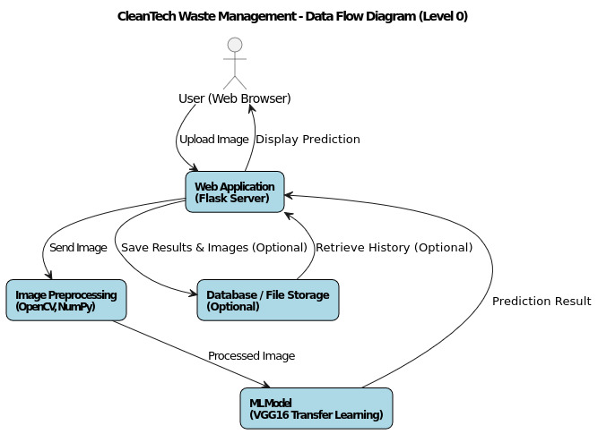

**User Stories**

| **User Type** | **Functional Requirement (Epic)** | **User Story Number** | **User Story / Task** | **Acceptance Criteria** | **Priority** | **Release** |
| --- | --- | --- | --- | --- | --- | --- |
| Customer (Web User) | Waste Classification | USN-1 | As a user, I can upload an image of waste for classification. | I can upload an image successfully and receive classification result. | High | Sprint-1 |
| Customer (Web User) | Waste Classification | USN-2 | As a user, I can view the predicted waste category and confidence score. | Prediction and confidence score are displayed clearly on the page. | High | Sprint-1 |
| Customer (Web User) | History Management | USN-3 | As a user, I can view my past waste classification results in a history section. | Past classification records are listed and accessible. | Medium | Sprint-2 |
| Customer (Web User) | User Interface | USN-4 | As a user, I want a simple, responsive web interface for upload and results. | The interface loads quickly and adapts to different devices. | High | Sprint-1 |
| Customer (Web User) | Model Update | USN-5 | As an admin user, I can update the ML model with new training data for better accuracy. | New model can be uploaded and applied without downtime. | Low | Sprint-3 |
| Administrator | Result Storage | USN-6 | As an admin, I want to save all classification results and images in a database for analytics. | Results and images are stored securely and retrievable. | Medium | Sprint-2 |